**Assignment – User Management**

1) Create user "nikhil" with home directory set as "/home/nikhil"

a) nikhil user should have "/bin/sh" shell for his environment

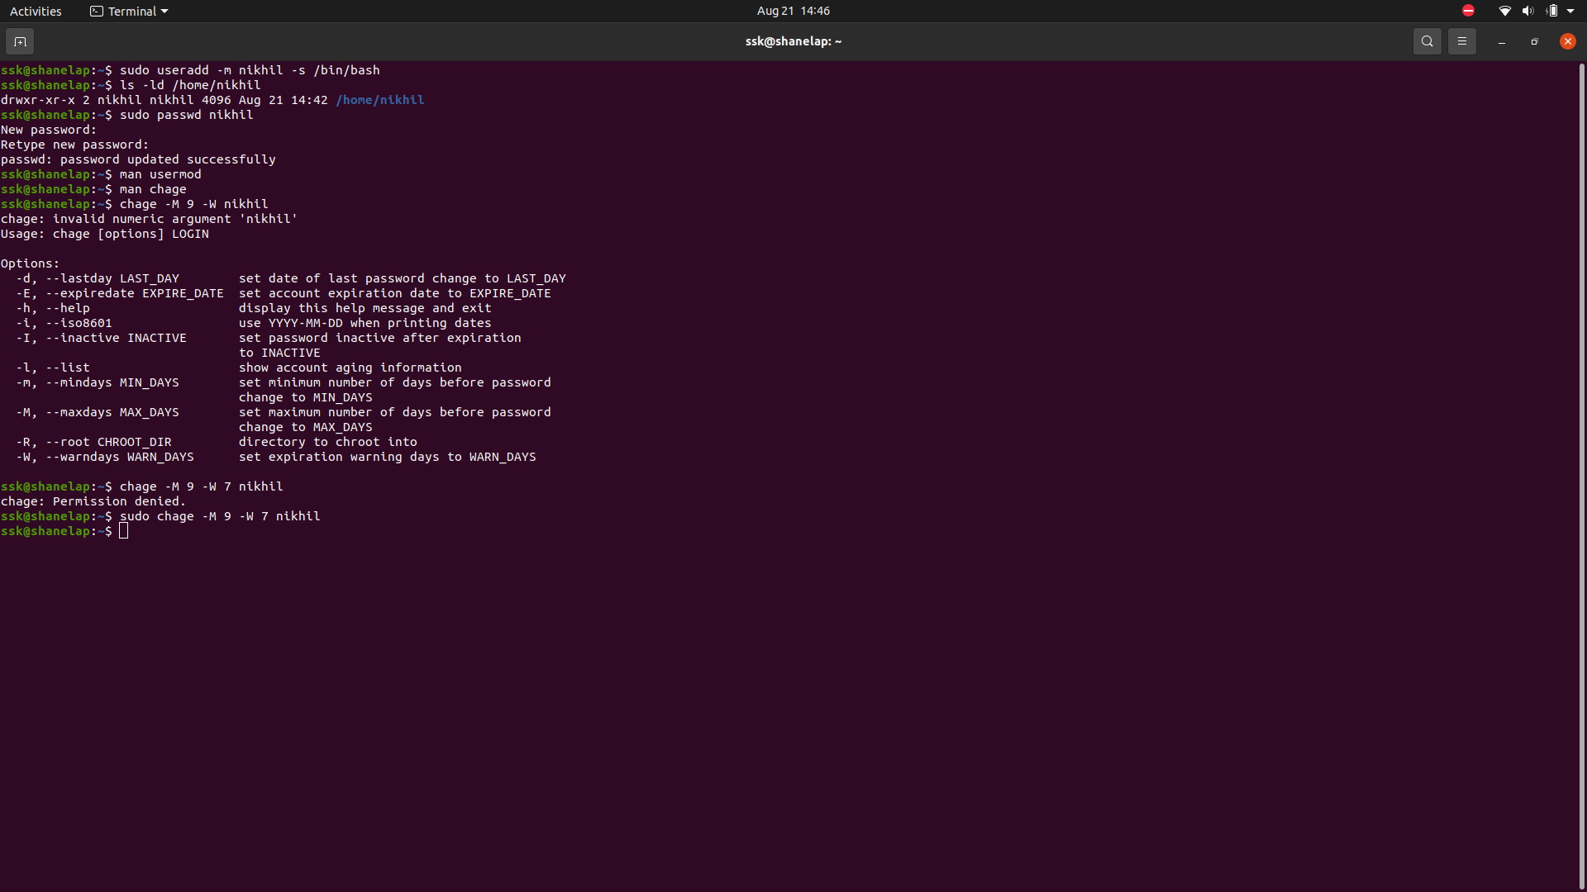

b) His password should expire in 9 days and 2 days before password expiry, he

should get warning. User account must expire in 1 month from creation date



c) Give him root privileges to start/stop cron daemon.

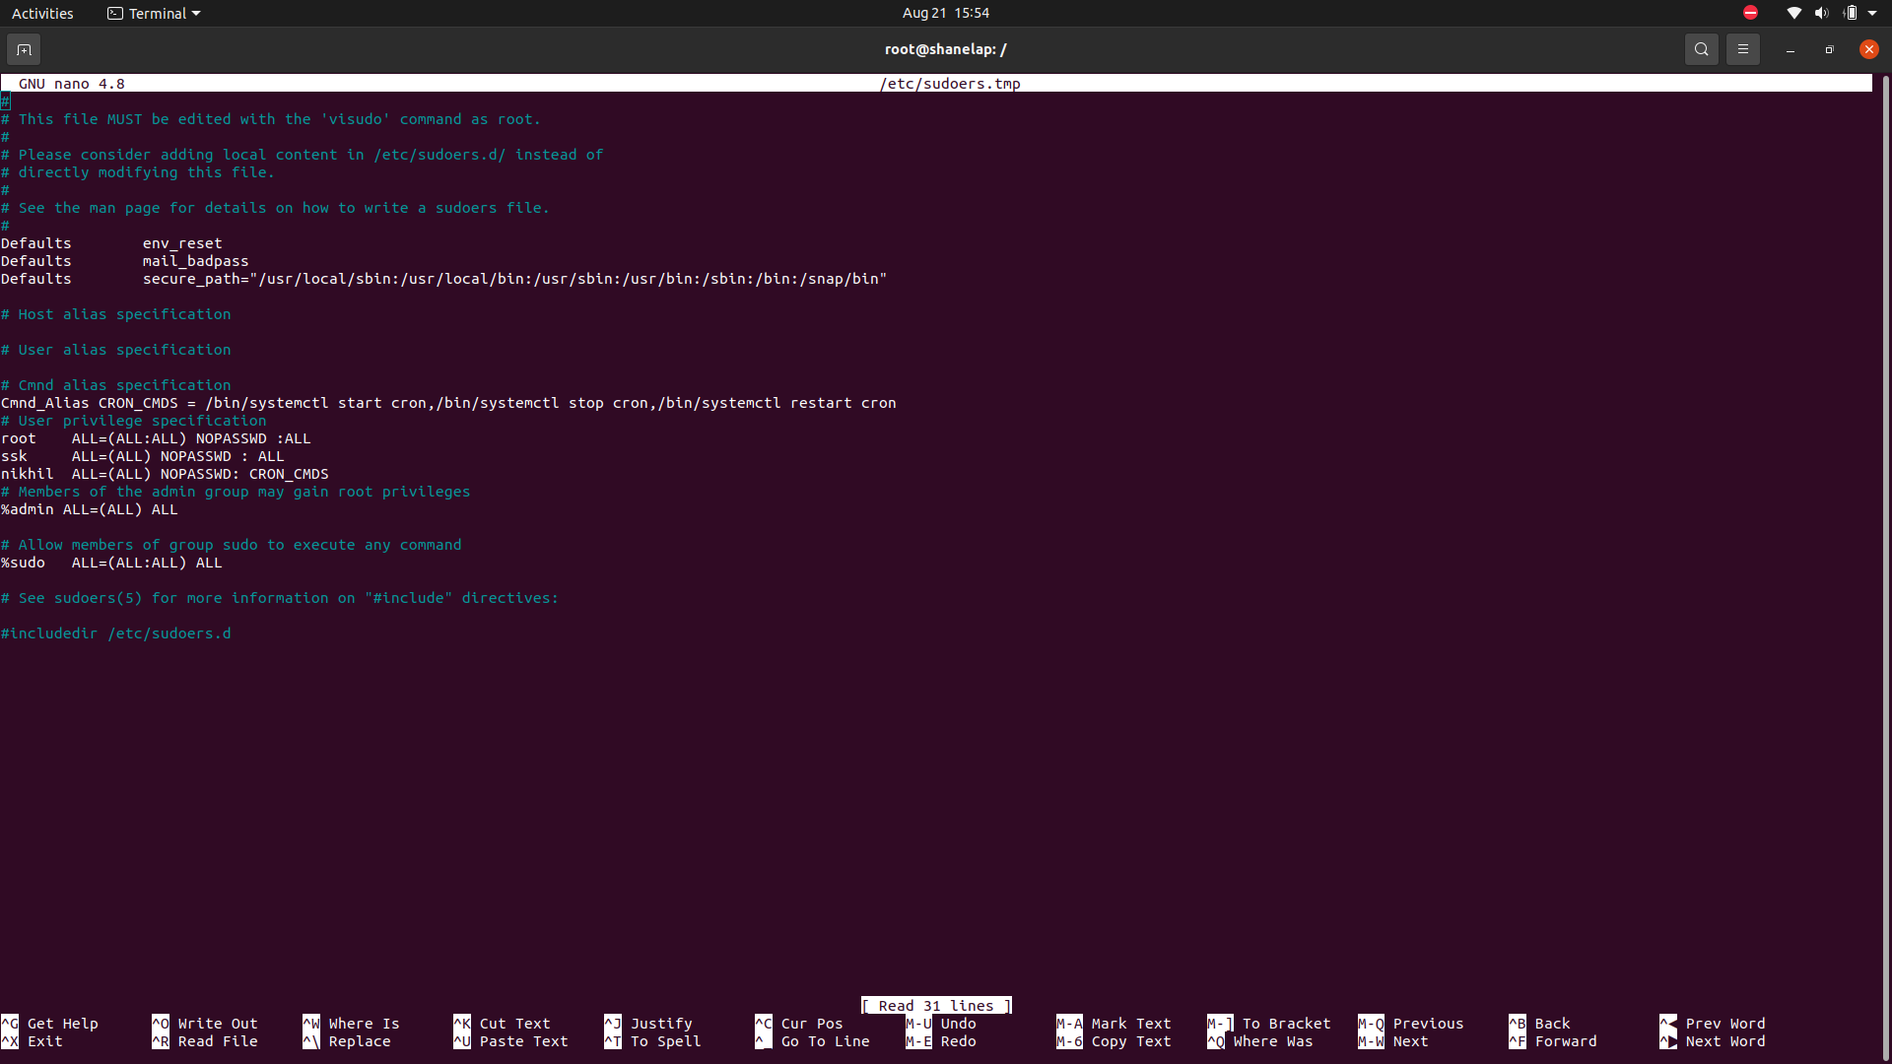

2) Inside folder "/" , create new home directory as "nikhil" (/nikhil) and setup this folder

as a home directory for user "nikhil"

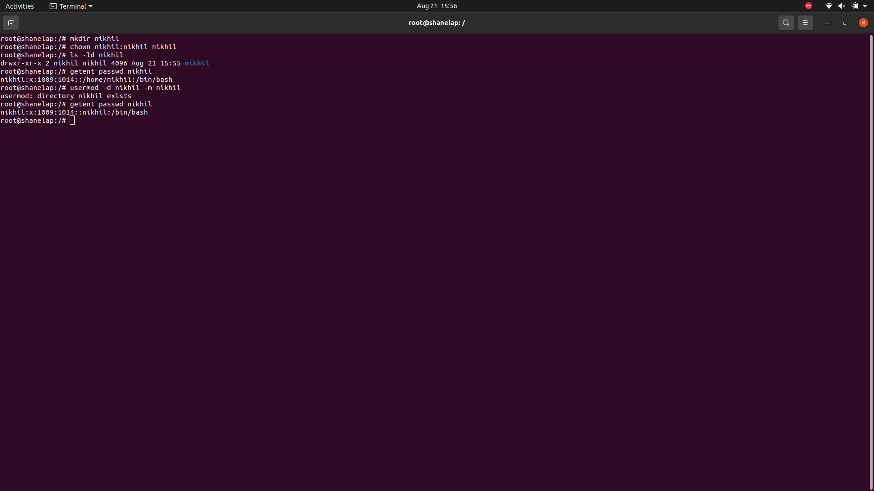f